Project Report: MAC Address Masking Tool in Kali Linux
Student/Developer: Amina Malik
Location: Pakistan
Date: August 2025
1. Project Overview
The MAC Address Masking Tool is a custom-developed utility in Kali Linux designed to enhance network privacy by automatically changing and masking the Media Access Control (MAC) address of network interfaces. This tool demonstrates practical knowledge of Linux networking, scripting, and ethical hacking principles.

2. Objective
- To develop a user-friendly script/tool that can mask or rotate MAC addresses on-demand.
- To improve understanding of network interface management in Linux.
- To showcase practical scripting and automation skills for ethical hacking and cybersecurity applications.

3. Tools and Technologies
- Operating System: Kali Linux
- Programming/Scripting: Bash
- Network Tools: macchanger, ip commands
- Text Editor: Nano / VS Code
- Version Control (optional): GitHub

4. Features
- Automatically changes MAC addresses to random values.
- Checks for root privileges before executing to ensure system safety.
- Brings network interfaces up and down automatically during the change process.
- Displays the updated MAC address for verification.
- Optional: can be extended to rotate MAC addresses automatically or provide a menu-driven interface.

5. Implementation
- Script Creation:
Developed a Bash script to interact with the Linux network stack and macchanger utility.
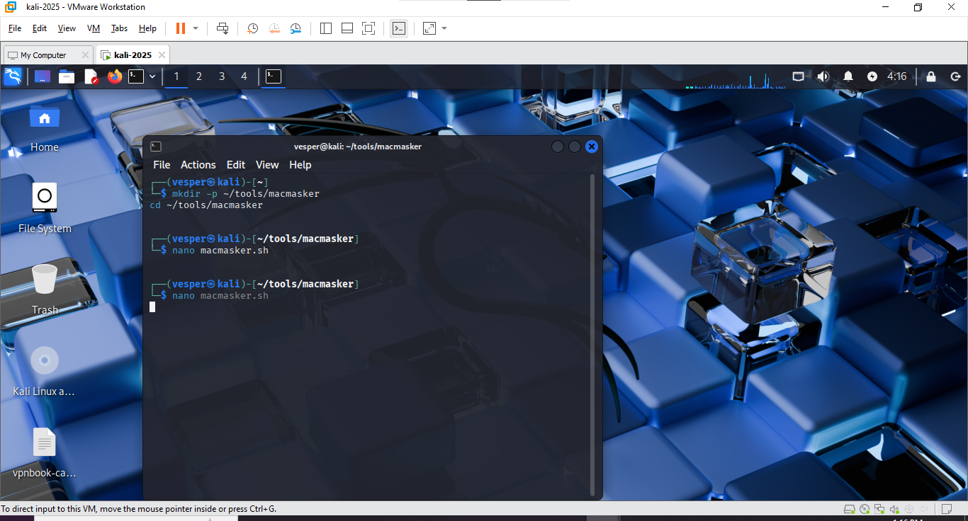
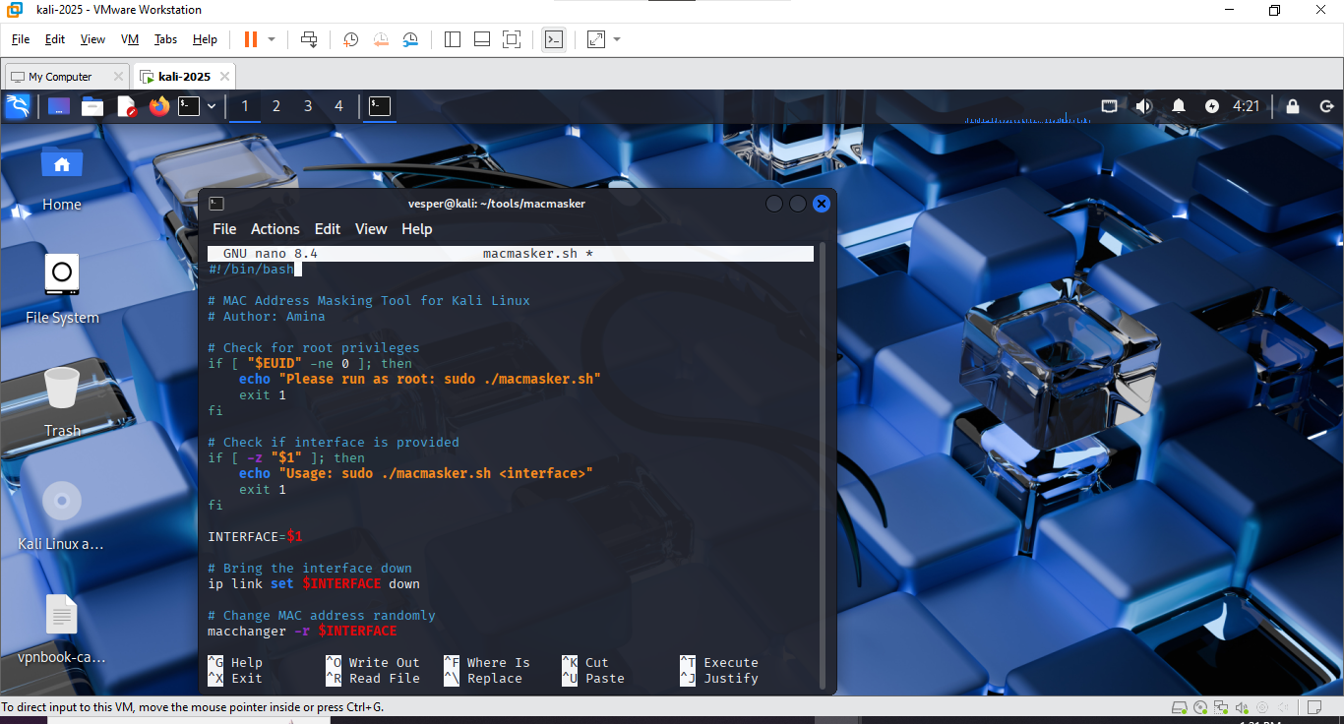
- Root Privilege Verification:
Ensures the tool is executed with appropriate permissions.
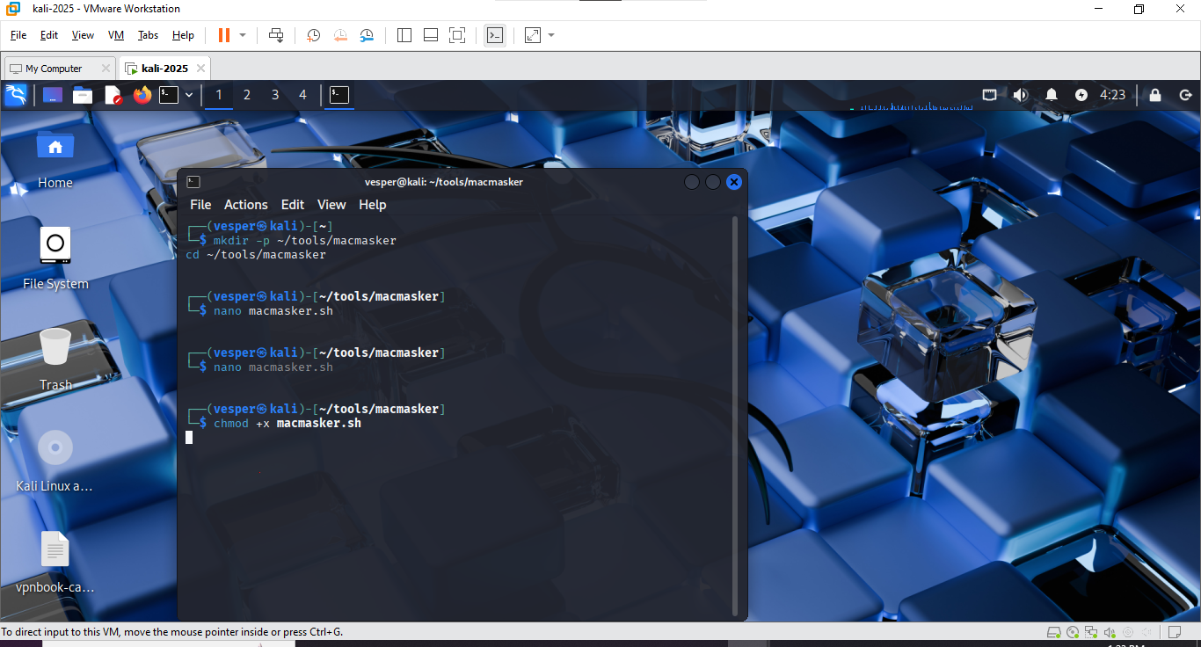
- Network Interface Management:
Uses ip link set <interface> down/up to safely apply MAC address changes.
- Random MAC Assignment:
Utilizes macchanger -r to generate random MAC addresses for privacy.
- User Feedback:
Prints the updated MAC address to allow the user to verify changes.
Example Usage:
sudo ./macmasker.sh eth0

7. Testing and Validation
Purpose: To verify that the MAC Address Masking Tool works correctly and reliably changes the MAC address of network interfaces without errors.
Testing Steps:
1.Run the tool with root privileges:
sudo ./macmasker.sh eth0
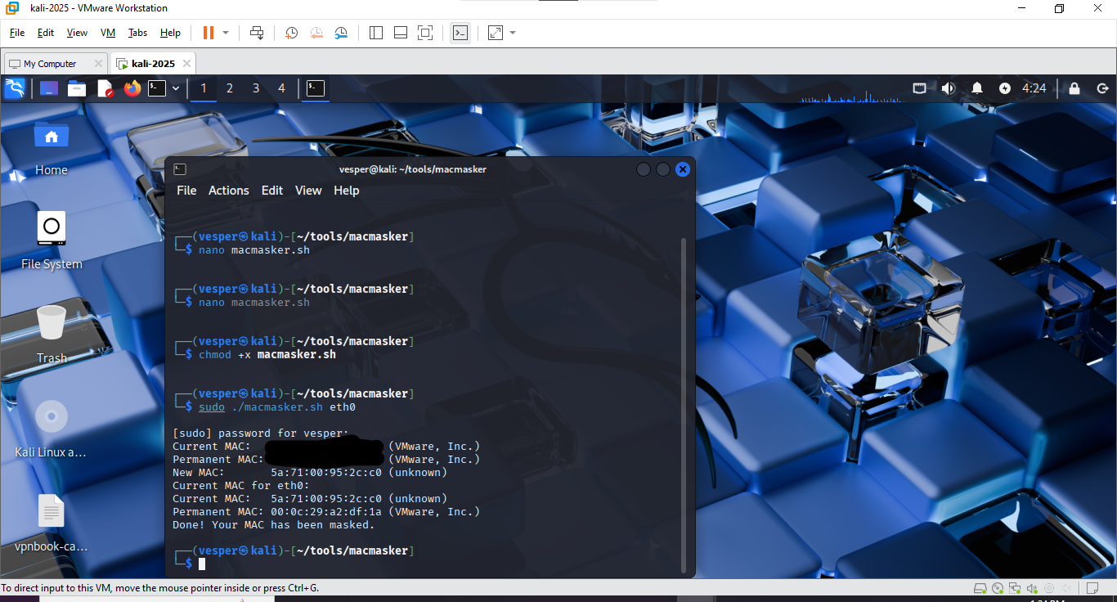
2.Observe output confirming MAC address change.
- Verify the new MAC address:
macchanger -s eth0
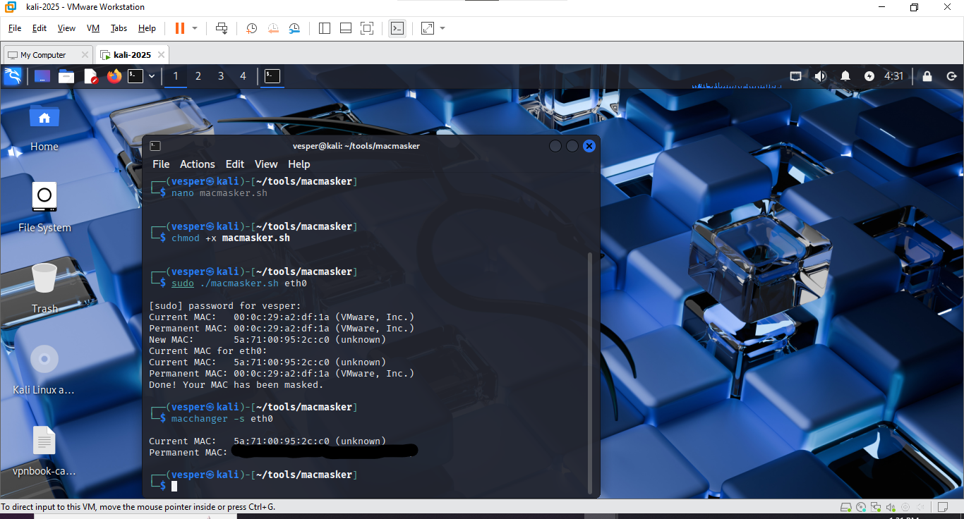
4.Repeat multiple times to confirm randomness and stability.
Outcome:
- Tool successfully changed MAC addresses on all test runs.
- Network connectivity restored automatically after each change.
- Random MAC generation confirmed for enhanced privacy.

9. Conclusion
This project showcases my ability to develop practical tools in Linux for network privacy and cybersecurity applications. It highlights my proficiency in scripting, ethical hacking concepts, and hands-on problem-solving, making it a valuable addition to my CV, GitHub portfolio, and LinkedIn profile.

